A Holistic Approach to Education
and Childhood Development

Curriculum Framework
Post 16

“Excellence, from Enrolment to Graduation”

Explanation of How the Curriculum Works
Rationale and Aims:
At Serenity School, We Care, Value and Challenge every child to achieve their true potential. In doing so, we improve life chances of our young people through an unwavering commitment to Inclusion, Independence and Self Worth for all learners. We can confidently say this because our curriculum is designed to deliver a holistic approach to education and childhood development.
Therefore, our Curriculum aims to develop the following 5 Core Principles of positive behaviour and action in everyone.
- We look after Ourselves: This part of our curriculum focuses on equipping pupils with the skills they need to become healthy and independent individuals able to care for themselves. Pupils continue to focus on ways in which they can reflect on their own personal development and how their personal skills, abilities and behaviours can be improved. They continue to learn different ways in which they can contribute to a healthy lifestyle and are encouraged to demonstrate activities which will improve their own lifestyle. They also begin to understand food and its functions in the body and learn how to prepare and cook healthy meals using basic skills. Attendance in PE is promoted through rewards to encourage an active lifestyle, improve self-esteem and social skills and increase competency in gross motor skills. Pupils also participate in Life Coaching to help them better manage their emotions and behaviour and consequently become more authentic and independent.

- We look after each Other: Students achieve more when they learn to care for each other. Hence this part of our curriculum aims to help pupils understand how to safely provide support to others, including knowing what they can and cannot do to support others and why. They also develop skills and behaviours needed to lead others and work as part of a team. They will participate in organising a coffee morning at the local hospice and in the planning and running of an enterprise activity within the school.

- We look after our Learning: We have very high expectations of our pupils and strongly believe that they should gain the relevant currency which they will need to participate fully in today’s rapidly changing society. As such, pupils are expected to achieve a minimum of 5 nationally accredited qualifications (including English and Maths) at Level 1 or Level 2 or a minimum of 5 GCSEs (including English, Maths & Humanities) at the end of Year 11. If not, they can continue to purse core subjects alongside a vocation curriculum at Post 16. They are also incentivised to develop a love of reading as well as positive behaviours for learning.

- We look after our School, Community and World: This part of our curriculum encourages pupils to care for our school community. They also begin to develop an awareness of their local community and gain the skills and confidence to use various local services and facilities. They will learn about the changing nature of society in the UK by examining the impact of migration and the benefits of cultural diversity. They will also develop an awareness of how to take responsibility for their environment by identifying environmental issues and how they can go about helping the environment.

- We look after our Futures: Pupils will be introduced to the key elements of managing their personal finances, encouraging them to prepare a personal budget and to carry out transactions capably. They will also develop problem solving skills to help them to tackle problems in their daily lives. Through our unique Careers Matrix, pupils will be gradually exposed to careers information to help them develop career awareness and assist them in making informed choices about their future. They understand why certain mindset qualities are attractive to employers and participate in work experience to enable them to see for themselves, what working in different careers could be like. We expect that they apply and gain a post 18 education, employment or apprenticeship place of their choice before they leave us.
Post 16 – Readiness for the Future
We look after Ourselves (options)  - Healthy Living (PSD)  - Attendance at PE - (70% Bronze, 80% Silver, 90% Gold)  - Cookery Skills (F&C)  - Developing Self (Emp)  - Star Life Coaching (60% Bronze, 70% Silver, 80% Gold) | % of standards met:  Bronze = 60%  Silver = 70%  Gold = 80+%
We look after each other
- Supporting Others (PSD) – Via WEX and apprenticeship experiences
- Developing leadership skills (Sports Leaders/CMI L2)
- Working as part of a group (PSD/Sports Leaders, CMI L2)
- Planning and running an enterprise activity (PSD/CMI L2)
 | Literacy/Numeracy | Options for More Able at GCSE | Vocational | Life Skills | B4L | Working in TEAMS
Bronze | Gained expected level of progress at L1 in M/E | On track for 1 or more at GCSE M/E/S/H | Pass in 1 Voc area L1 | Pass 1 course at L1/L2  (IT or Emp) | 100+ points | Complete the 3 day residential CMI course in TEAM  Complete business start up project and achieve L2 Award
Silver | Gained expected level of progress across both at L1 or L2 | Grade 3/4 or better | Pass in 2 Voc areas at L1/L2 | Pass in 2 at L1/L2  IT, LiFE,  EMP, SL, Sports | 250+ points
Gold | GCSE Maths and English at Grade 4+ or L2 in at least 1 subject | Grade 4/5 or better | Distinction in 1 Voc area at L1/2  Pass in 2 Voc areas at L2 Award | Pass 3 areas L1/L2  Employability  LiFE, ICT, Sports,  Sports Leaders  PSHE (PSD) | 400+points
We look after our learning
We look after our School, community and world
- Myself within the community (EmpWork Experience)
- Environmental Awareness (PSD/Science)
- Rights and responsibilities/The changing nature of society in the UK/Understanding personal identity (PSD)
We look after our futures
- Complete Careers Programme – IAG Interviews, L1/2 in Emp, CV ready, 3 visits to Post 18 providers & 3 Applications sent
- Careers matrix (60% Bronze, 75% Silver, 90% Gold)
- Manging money (LiFE)
- Dealing with problems in everyday life (PSD/Life Coaching Targets)
- Attendance (87% Bronze, 90% Silver, 92% Gold)

An Organic Curriculum
Each of the five component sections of the curriculum is designed organically to develop each pupil at an individual level to ensure each one has a curriculum offer that is bespoke to them and challenges them from their own individual starting point. In doing so, pupils have every opportunity to make progress at Bronze – Sliver - Gold Standards in their overall Key Stage Curriculum. Each pupils timetable and progression pathway are set by SLT after they complete a series of assessments and have achieved their year 11 grades. Once the data is available an Academic Flightpath is put in place and shared with parents and staff. Pupils, parents and staff are therefore held to account to ensure standards of progress is achieved along the way and measured termly. We call this process; Stepping Stones to Milestones.
Key Performance Indicators are strategically tracked for each pupil, and therefore, with the correct level of support in place in classrooms, at external provers and in 1-1 sessions we ensure that all pupils leave school in year 13 with good qualifications in math, English that range from Level 1 to GCSE. As we support and guide students through a layered and phased build to year 13 students will improve upon earlier qualifications in vocational and life skills with the aim of achieving level 2 and 1 qualification respectively.
Academic progress is tracked alongside SEND targets and when combined, contribute to the overall achievement of our Socio-Education Model for each pupil.
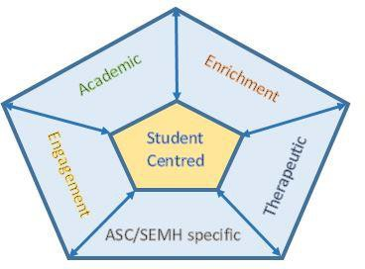
Socio-Education Model

Socio- Education Model | Performance Outcomes
Academic | - SS Vocational Award – 100% of Year 13 pupils achieving bespoke offer including maths and English at Level 1 or better  - 80% of pupils making substantial and sustained progress in year
SEND | - 80% of pupils making expected progress of EHCP targets
Engagement | - All pupils achieving Bronze to Gold – Holistic tracker of 5 Core Positive Actions and Behaviour  - 0% NEET
Enrichment | - 80% of pupils completing a Leadership Qualification for improved self confidence  - 80% of pupils accessing SMSC curriculum
Therapeutic – SEMH | - 90% of pupils improving their understanding of SEMH barriers using Social and Emotional Toolkit – STAR Life Coaching

Post 16 Vocational Baccalaureate Curriculum – Rewards & Incentives
About the VB Award:
This is an Award that challenges pupils to develop themselves into a complete all-round person, equipped with the skills to do well, in school and life.
It develops a growth mindset and will ensure that they achieve an awareness of our 5 Core Principles of Positivity in their life on a regular basis and apply them to themselves and others.
In addition, it challenges them to achieve qualifications by the end of Year 13 and motivates them to work on their own life coaching, so they leave with confidence and independence.
Pupils gaining Bronze to Gold Awards will automatically be assured a place at one of our approved apprenticeship or college providers.
How it Works:
We want ALL pupils to achieve their full potential and in doing so we will help you by offering rewards and incentives along the way to ensure you stay motivated and on track.
Each fortnight there will be a rewards assembly and those pupils on track to achieve the VB Award as well as pupils who are showing strong commitment and resilience to our 5 Core Principles of Positivity will be recognised and awarded spot prizes as a celebration of efforts made.
Types of Rewards and prizes:
There will be 2 assemblies a month as well as End of Term and End of Year celebrations
Type of Award | Prizes and Incentives
1st Instant Recognition Awards  # Set your timeline, focus on your goal and get paid for it! | Every time you complete a unit of work from the Vocational and Life Skills Courses and your teacher confirms this you receive;  £25.00  Each time you pass a complete course at the set level you receive;  £50.00.  This includes Math and English qualifications
2nd – Assembly (a) of the Month is the “Commitment and Resilience Awards”  You have to be attending school regularly and participating to your potential to win!! | £10.00 Vouchers allocated to a range of progress measures such as  - Attendance  - most improved  - best work in subject  - unit completed  - strong resilience  - going above and beyond et al
3rd Assembly (b) of the Month is the VB Awards Day “Who’s developing a Growth Mindset and making overall progress  #The Prize Generator will automatically select your prize | - Mystery Gift Bag (Something fun or financial in it)  - Listen to Music While You Work (With headphones or they can bring in their own music and earbuds)  - Gain 50 reward points  - Receive a personalised item from the school to celebrate your success (up to the value of £50.00)  - Positive Phone Call or post card Home  - Ask the Teacher for an Answer on a Test  - VIP for the Day  - Get Out of Class 5 Minutes Early for a day  - Remove consequence points from your total for the term - 50 points  - Leave Me Alone Pass (don't get called on or have to participate all day)  - Free Pass from 1 subject for a day  - Teacher Brings a Special Snack for You or orders a special lunch meal of your choice with one friend.
The 4th is the Headteachers End of Term Assembly with some special recognitions | Bespoke Prizes throughout the year ahead as agreed by the Headteacher when achieving a combination of qualification units or courses completed on time;  - Tickets to Premiere Football match  - London West End Show  - Day at the racetrack – carting  - Day with a DJ at the Studio or other special work experience  - Anything else agreed with SLT bespoke to you  - Head teacher Award – Citizenship Award  - End of Term Trip if the group is on track
There will also weekly awards published on the Headteachers Awards Notice Board for weekly best and most improved pupils.

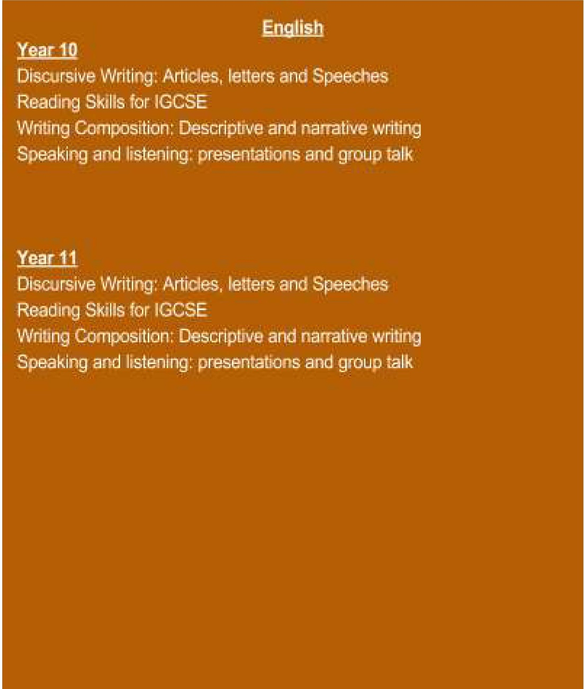
Year 12/13
Calculating
Visualising and constructing
Algebraic proficiency: tinkering
Proportional reasoning
Patterns and sequences
Solving equations and inequalities I
Calculating space
Conjecturing
Algebraic proficiency· visualising
Solving equations and inequalities II
Understanding risk
Presentation of data

Investigating properties of shapes
Calculating, Visualising and constructing
Solving equations and inequalities I
Mathematical Movement I
Algebraic proficiency: tinkering
Proportional reasoning
Patterns and sequences
Calculating space
Exploring fractions, decimals and percentages
Algebraic proficiency: visualising
Solving equations and inequalities II
Analysing Statistics
Mathematical Movement 11
Hair and Beauty
Customer service skills, Hand & nail care, Foot and toenail car, Make Up application, Nail Art, Skin care, Shampoo/condition/Blow dry hair, Plaiting and twisting,
Colouring/highlighting/Setting/curling/Cutting of Hair

Animal Care
Looking after animals through practical experience, Handling animals safely, Animal health , Work experience placement

Health and Social Care
Understand the range of service provision and roles within health and social care, Principles and values in health and social care, Awareness of health and safety in health, social care and children’s and young people’s settings
Art & Craft
Use Materials, Tools and Equipment to Develop Craft Techniques, Investigate Creative Enterprise and Employment Opportunities,
Develop Craft Ideas
Create, Present and Evaluate Final Craft Item
Food Technology
Preparing to Cook, Understanding food, Exploring balanced diets, Plan and produce dishes in response to a brief

PSHE
Preparation for work,
Understanding Personal Identity
Investigating a vocational area
Preparing for your next steps
Sports Leadership/Coaching
Developing leadership skills, Plan, assist in leading and review a sport/physical activity session, Participating in Sport, Sports Coaching, Developing Sporting Skills and Tactical Awareness, Work Experience in the Sports Industry
Motor Mechanic
Engine systems 1
Chassis systems 1
Vehicle systems practical 1

IT
Functional Skills in Information and Communication Technology
Business
Introduction to business and enterprise, Marketing,
Finance, planning, and taking part in a business or enterprise project
Employability Skills
Understanding mindset, Work awareness, understanding money at work, writing CV, Searching and applying for a job
Travel and Tourism
Customer Service, Communication Skills, Hospitality, Travel and Tourism Facilities in the UK, Working in Travel and Tourism, Careers in Travel and Tourism, Work Experience in Travel and Tourism

Interventions

Life coaching
1. Education and Health (Self-awareness SEN specific, Focus and Attention, Staying Healthy).
2. Social and Communication (Taking responsibility for actions, Maintaining Relationships, Communicating and Interacting with others).
3. Psychological Wellbeing (Managing Anxiety, Thinking and Reacting, Self-esteem.

Numeracy Skills

Adding, subtracting, dividing, multiplying, times tables, problem solving, number bonds, counting, sequences

Literacy Skills
Handwriting, reading decoding, spelling, reading comprehension, phonics, writing composition, reading fluency

Therapeutic

Pro social behavior, strengths and difficulties, Relationships.

Year Group | Subject | Independent Schools Guidance Areas
 |  | Linguistics | Mathematical | Scientific | Technological |  | Human and Social | Physical | Aesthetic and Creative | PSHE
Year 12 & 13 | English | ✔ | ✔ |  |  | ✔ |  |  | ✔ | ✔
 | Maths | ✔ | ✔ | ✔ | ✔ |  |  |  |  | ✔
 | Food Technology | ✔ | ✔ | ✔ | ✔ | ✔ |  |  | ✔ | ✔
 | Art & Craft, Design Technology | ✔ | ✔ | ✔ | ✔ | ✔ |  |  | ✔ | ✔
 | Motor Mechanics | ✔ | ✔ | ✔ | ✔ | ✔ |  | ✔ | ✔ | ✔
 | Health and Social Care | ✔ |  | ✔ | ✔ | ✔ |  | ✔ |  | ✔
 | IT | ✔ | ✔ | ✔ | ✔ |  |  | ✔ | ✔ | ✔
 | Travel and Tourism | ✔ |  |  |  | ✔ |  |  | ✔ | ✔
 | LiFE | ✔ | ✔ |  |  | ✔ |  | ✔ |  | ✔
 | Sports Coaching | ✔ | ✔ | ✔ |  | ✔ |  | ✔ | ✔ | ✔
 | PSHE | ✔ | ✔ | ✔ |  | ✔ |  | ✔ |  | ✔
 | Sports Leaders Award | ✔ | ✔ | ✔ |  | ✔ |  | ✔ |  | ✔
 | Employability Skills | ✔ | ✔ |  |  | ✔ |  | ✔ | ✔ | ✔
 | Animal Care | ✔ | ✔ |  |  | ✔ |  | ✔ | ✔ | ✔
 | Hair and Beauty | ✔ | ✔ |  |  | ✔ |  | ✔ | ✔ | ✔
 | Business & Enterprise | ✔ | ✔ |  | ✔ | ✔ |  | ✔ | ✔ | ✔

Accreditation Map
Qualification Name |  |  |  |  | Level | Credit Value | TQT/GLH | Unit Details
NCFE Functional Skills Maths |  |  |  |  | EL1 | 0 | 45 | Not unitised
600/0793/x
NCFE Functional Skills Maths |  |  |  |  | EL2 | 0 | 45 | Not unitised
600/1218/3
NCFE Functional Skills Maths |  |  |  |  | EL3 | 0 | 55 | Not unitised
603/5061/1
NCFE Functional Skills Maths |  |  |  |  | L1/L2 | 0 | 55 | Not unitised
603/5055/6
NCFE Functional Skills English 603/5059/3 |  |  |  |  | EL1 | 0 | 61/55 | Not unitised
NCFE Functional Skills English 603/5056/8 |  |  |  |  | EL2 | 0 | 61/55 | Not unitised
NCFE Functional Skills English 603/5052/0 |  |  |  |  | EL3 | 0 | 61/55 | Not unitised
NCFE Functional Skills English 501/1660/5 |  |  |  |  | L1 | 0 | 61/55 | Not unitised
NCFE Functional Skills English 600/0140/9 |  |  |  |  | L2 | 0 | 54/45 | Not unitised
WJEC Independent Living |  |  |  |  | E3/L1/2 | 8+ = Award  13+= Certificate  37+=Diploma | 80 | Myself within the community (H/503/2779)- 20hrs  Developing Self (M/502/0456)- 20hrs  Dealing with problems in everyday life (H/502/0454)-20hrs  Managing Money (F/502/0462)- 20hrs
NCFE Level 1 Award in Creative Craft  (Art and Design) 601/3360/0 |  |  |  |  | L1 | 9 | 90/80 | D/506/2654 - Explore craft resources (3 credit/30hrs) Mandatory  H/506/2655 - Explore craft ideas (4 credits/30 hrs)  L/506/2648 - Create, present and review final craft item (2 credits/20hrs)
NCFE Level 2 Award in Creative Craft 601/3232/2 |  |  |  |  | L2 | 15 | 150/110 | Use Materials, Tools and Equipment to Develop Craft Techniques (M/506/2674)  Investigate Creative Enterprise and Employment Opportunities (K/506/2673)  Develop Craft Ideas (H/506/2672)  Create, Present and Evaluate Final Craft Item (T/506/2675)
NCFE Entry Level 3 Award in Employability Skills (601/4678/3) |  |  |  |  | E3 | 6 | 60/36 | Unit 01 Understanding mindset (F/506/7216) - 12hrs Mandatory  Unit 06 Work awareness (Y/506/7254) - 20 hours  Unit 21 Understanding money at work (A/502/4316) - 20 hours
NCFE Certificate in Employability Skills  601/4681/3 |  |  |  |  | L1 | 6 | 60/36 | 1. Understanding Mindset (J/506/7234) - 12hrs Mandatory - 2 Credits)  30. Job and Training Search Skills (D/502/3613) - 1 Credit)  31. Job Application Skills (H/502/3614) - 1 Credit)  32. Interview Skills (K/502/3615) - 1 Credit  33. Writing a CV (J/502/3038) - 2 Credits
NCFE Level 1 Certificate in Food and Cookery Skills  (603/3909/3) |  |  |  |  | L1 | 18 | 180/120 | Unit 01 Preparing to cook (H/506/7550) – 30hrs Mandatory  Unit 02 Understanding food (K/506/7551) – 30hrs  Unit 03 Exploring balanced diets (M/506/7552)- 30hrs  Unit 04 Plan and produce dishes in response to a brief (T/506/7553) – 30hrs
NCFE Level 2 Certificate in Food and Cookery Skills  (603/3909/3) |  |  |  |  | L2 | 18 | 180/120 | - Preparing to Cook (D/506/5036)  - Understanding Food (H/506/5037)  - Exploring Balanced Diets (K/506/5038)  - Plan and Produce Dishes in Response to a Brief (M/506/5039)
Sports Leaders SL1 601/8579/X |  |  |  |  | L1/L2/L3 | 3/5/13 | 31/23 | Unit 1 – Developing leadership skills – 11hrs  Unit 2 – Plan, assist in leading and review a sport/physical activity session 20hrs
NCFE Level 2 Certificate in Sport (Sports Coaching)  601/3037/4/COA |  |  |  |  | L2 | 24 | 240/180 | - Participating in Sport (M/505/9936)  - Sports Coaching (T/505/9937)  - Developing Sporting Skills and Tactical Awareness (D/505/9981)  Work Experience in the Sports Industry (J/505/9974)
NCFE Level 1 Award in Personal and Social Development (501/0672/7) |  |  |  |  | L1 | 7+ | 70/70 | Unit 04 Environmental awareness (Y/502/0659) – 20hrs  Unit 05 Healthy living (F/502/0476) – 20hrs  Unit 6 Individual Rights and Responsibilities (K/502/0472)  Unit 16 The Changing Nature of Society in the UK (K/600/3164) – 10hrs  Unit 17 Supporting others (H/501/6887) – 30 hrs
NCFE Level 1 Certificate in Personal and Social Development (501/0591/7) |  |  |  |  | L1 | 15 | 150/150 | Unit 11 Preparation for work (J/502/0477) – 20 hrs  Unit 18 Understanding Personal Identity (M/600/3134) – 10hrs  Unit 19 Investigating a vocational area (T/600/3250) – 20HRS  Unit 20 Preparing for your next steps (L/601/0110) – 40HRS
NCFE Functional Skills Qualification in Information and Communication Technology (ICT) at Level 1 600/0030/2 |  |  |  |  | L1  L2 | 5 | 52/45 | Information and Communication Technology
City and Guilds Level 1 IVQ Certificate in Motor Vehicle Systems (500/5966/X) |  |  |  |  | L1  L2 | 45 | 495/450 | Engine systems 1  Chassis systems 1  Vehicle systems practical 1
City and Guilds Level 1 IVQ Certificate in Motor Vehicle Systems (500/5967/1) |  |  |  |  | L2 | 45 | 495/450 | Chassis systems 1  Maths, Science and communications  Vehicle systems practical 1
NCFE Level 1 Award in Introduction to Health, Social Care and Children's and Young People's Settings (600/1211/0) |  |  |  |  | LI | Award = 10  Certificate = 25 | 101/86  250/212 | - Intro MU 1.1 Understand the range of service provision and roles within health and social care (adults and children and young people), early years and childcare) A/602/6187) – 3 credits  - Intro MU 1.2 Understand the principles and values in health and social care (adults and children and young people), early years and childcare (J/602/6189) – 3 credits  - PWCS 04 Introductory awareness of health and safety in health, social care and children’s and young people’s settings (Y/502/9717) – 4 credits
NCFE Level 2 Certificate in Health and Social Care  601/8854/6 |  |  |  |  | L2 | 20 | 210/180 | HSC M1 Equality, diversity and rights in health and social care (L/508/3709) – 7 Credits  HSC M2 Human growth and development (F/508/3710) – 7 Credits  HSC M3 Safeguarding and protection in health and social care (J/508/3711) – 7 credits
NCFE Level 1 Certificate in Travel and Tourism  (601/3230/9) |  |  |  |  | L1 | 18 | 180/118 | - Customer Service in Travel and Tourism (D/506/2301)  - Communication Skills in Travel and Tourism (H/506/2302)  - Travel and Tourism Facilities in the UK (K/506/2303)  - Hospitality in Travel and Tourism (M/506/2304)  10. Working in Travel and Tourism (F/506/2310)  13. Careers in Travel and Tourism (R/506/2313)
NCFE Level 2 Certificate in Travel and Tourism  (601/6266/1) |  |  |  |  | L2 | 24 | 360/240 | - Customer Service in Travel and Tourism (T/507/2655)- 60 hrs  - The UK Travel and Tourism Industry (A/507/2656) – 60 hrs  4. Promotion in Travel and Tourism (J/507/2658) – 60hrs  15. Work Experience in Travel and Tourism (M/507/2668) - 64 hrs
NCFE Level 1 Certificate in Business and Enterprise  (601/0315/2) |  |  |  |  | L1 | 12 | 180/120 | Unit 01 Introduction to business and enterprise  Unit 02 Marketing for business and enterprise  Unit 03 Finance for business and enterprise  Unit 04 Plan, outline and take part in a business or enterprise project
NCFE Level 2 Diploma in Business Administration (601/3964/X)  Level 3 Certificate (601/7074/8)  Level 3 Diploma (601/3965/1) |  |  |  |  | L2/L3 | 45 | /450 | Unit 01 Communication in a business environment (3 credits)  Unit 02 Understand employer organisations (4 credits)  Unit 03 Principles of providing administrative services (4 credits)  Unit 04 Principles of business document production and information management (3 credits)  Unit 05 Manage personal performance and development (4 credits)  Unit 06 Develop working relationships with colleagues (3 credits)  Plus 25 Extra Credits
Introduction to Animal Care |  |  |  |  | L1 | - | - | Looking after animals through practical experience  The correct ways to work with and handle animals safely  Animal health and how to spot signs of ill health  The conservation of wild animals  Work experience placement
Diploma in Animal Care | L2/3 | - | - | Practical animal health skills  The factors impacting animal welfare  Animal biology and health  Animal feeding  Animal behaviour  Safe handling and restraint techniques  Accommodation design and maintenance
Hair & Beauty | L1/L2/L3 | - | - | Customer service skills, Hand & nail care, Foot and toenail car, Make Up application, Nail Art, Skin care, Blow dry hair, Shampoo and condition hair, Retail displays, Plaiting, and twisting hair,  Colouring / highlights, Setting / finger waves / pin curls/Cutting of Hair

